Overview
File uploads are one of the most exploited attack vectors in web applications. For Eartigo specifically, the risk is elevated because uploaded files include KYC documents containing Aadhaar card scans, high-resolution drone imagery tied to GPS coordinates, and financial proof documents — all of which are SPDI-class data under the IT Act 2000 and personal data under the DPDP Act 2023.
A single misconfigured upload endpoint can allow an attacker to upload a malicious script disguised as a product photo, overwrite another farmer's KYC document by predicting a filename, or access sensitive farm imagery by guessing a storage path. Every control in this part is mandatory unless explicitly marked as recommended.

Upload Types on Eartigo

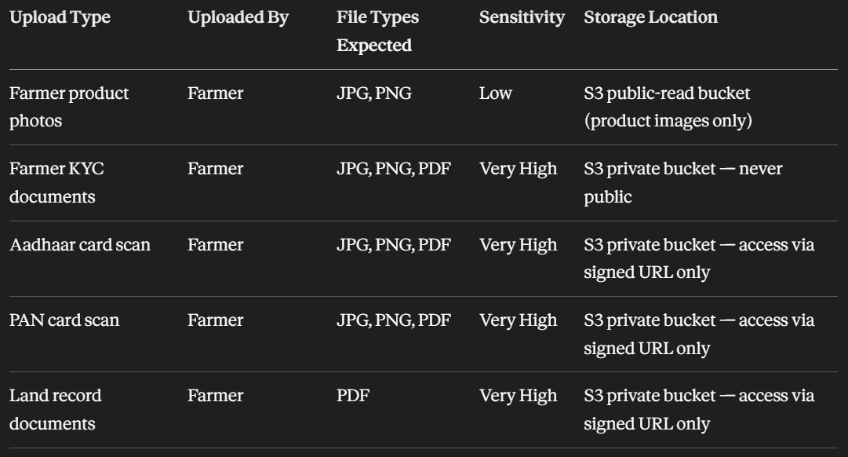
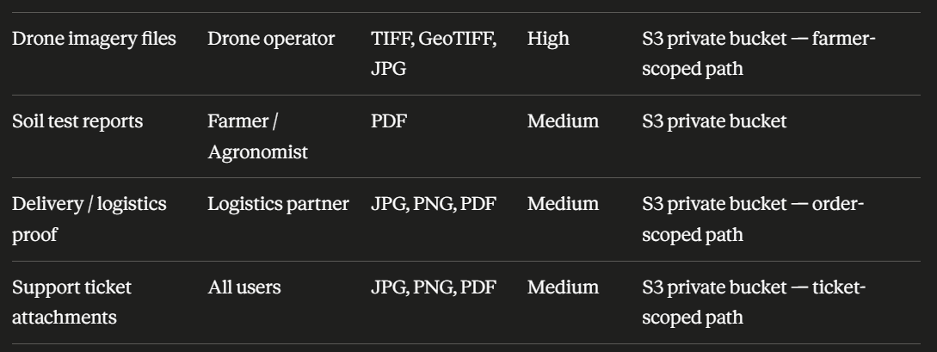

Upload Security Controls — Requirements Table

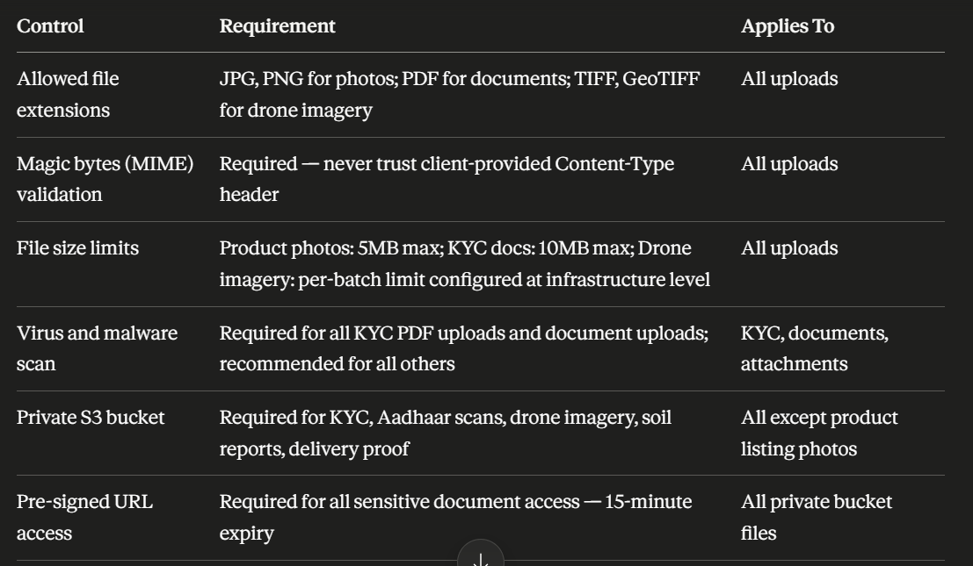
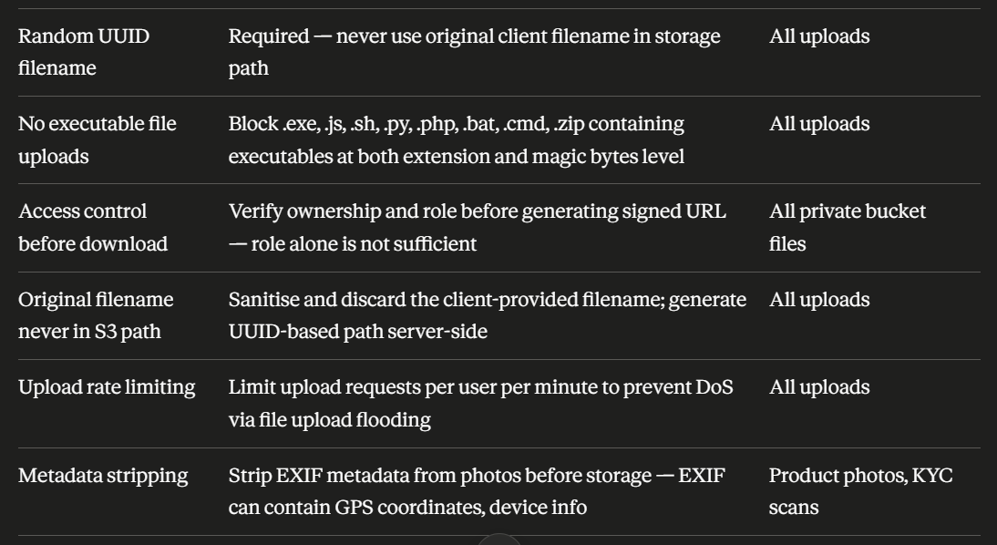

Secure File Path Structure
The file path used in S3 must never be predictable, never contain the original client filename, and must be scoped to the owning entity so that paths cannot be guessed across users.
// BAD — predictable, guessable, contains original filename
/uploads/farmer-aadhaar.pdf
/uploads/farmer123-pan.pdf
/kyc/john_pan_card.pdf

// GOOD — private, scoped, randomised, timestamped
private/farmers/{farmerId}/kyc/{uuid}-{timestamp}.pdf
private/farmers/{farmerId}/kyc/{uuid}-{timestamp}.jpg
private/farms/{farmId}/drone/{date}/{uuid}.tif
private/farms/{farmId}/soil-reports/{uuid}.pdf
private/orders/{orderId}/delivery-proof/{uuid}.jpg
private/support/{ticketId}/attachments/{uuid}.pdf

// Access only via pre-signed URL with 15-minute expiry — never via direct S3 URL

Full Implementation — Multer + Magic Bytes + S3
This is the complete, production-ready upload handler the development team should use as the foundation for all Eartigo upload endpoints. It enforces all mandatory controls in the correct sequence.

Step 1 — Install Dependencies

npm install multer @aws-sdk/client-s3 @aws-sdk/s3-request-presigner file-type uuid sharp

Step 2 — Upload Configuration Module

// config/uploadConfig.js

const UPLOAD_LIMITS = {
product_photo: 5 * 1024 * 1024, // 5MB
kyc_document: 10 * 1024 * 1024, // 10MB
drone_imagery: 200 * 1024 * 1024, // 200MB — batch limit handled separately
soil_report: 10 * 1024 * 1024, // 10MB
delivery_proof: 5 * 1024 * 1024, // 5MB
support_attachment: 5 * 1024 * 1024, // 5MB
};

const ALLOWED_MIME_TYPES = {
product_photo: ['image/jpeg', 'image/png'],
kyc_document: ['image/jpeg', 'image/png', 'application/pdf'],
drone_imagery: ['image/tiff', 'image/geotiff', 'image/jpeg'],
soil_report: ['application/pdf'],
delivery_proof: ['image/jpeg', 'image/png', 'application/pdf'],
support_attachment: ['image/jpeg', 'image/png', 'application/pdf'],
};

// Magic bytes signatures — ground truth, never trust client MIME
const MAGIC_BYTES = {
'image/jpeg': [0xFF, 0xD8, 0xFF],
'image/png': [0x89, 0x50, 0x4E, 0x47],
'application/pdf': [0x25, 0x50, 0x44, 0x46], // %PDF
'image/tiff': [[0x49, 0x49, 0x2A, 0x00], // Little-endian TIFF
[0x4D, 0x4D, 0x00, 0x2A]], // Big-endian TIFF
};

// Executable extensions — always blocked regardless of MIME
const BLOCKED_EXTENSIONS = [
'.exe', '.js', '.mjs', '.sh', '.bash', '.py', '.php',
'.pl', '.rb', '.bat', '.cmd', '.ps1', '.vbs', '.jar',
'.dll', '.so', '.elf', '.com', '.scr', '.hta',
];

module.exports = { UPLOAD_LIMITS, ALLOWED_MIME_TYPES, MAGIC_BYTES, BLOCKED_EXTENSIONS };

Step 3 — Magic Bytes Validator

// utils/validateMagicBytes.js
const { MAGIC_BYTES, BLOCKED_EXTENSIONS } = require('../config/uploadConfig');
const path = require('path');

function checkMagicBytes(buffer, expectedMime) {
const signatures = MAGIC_BYTES[expectedMime];
if (!signatures) return false;

// Handle multiple valid signatures (e.g. TIFF has two)
const sigList = Array.isArray(signatures[0]) ? signatures : [signatures];

return sigList.some(sig =>
sig.every((byte, i) => buffer[i] === byte)
);
}

function hasBlockedExtension(originalName) {
const ext = path.extname(originalName).toLowerCase();
return BLOCKED_EXTENSIONS.includes(ext);
}

function detectMimeFromBuffer(buffer) {
for (const [mime, sigs] of Object.entries(MAGIC_BYTES)) {
const sigList = Array.isArray(sigs[0]) ? sigs : [sigs];
if (sigList.some(sig => sig.every((byte, i) => buffer[i] === byte))) {
return mime;
}
}
return null;
}

module.exports = { checkMagicBytes, hasBlockedExtension, detectMimeFromBuffer };

Step 4 — Upload Middleware Factory

// middleware/uploadMiddleware.js
const multer = require('multer');
const { UPLOAD_LIMITS, ALLOWED_MIME_TYPES } = require('../config/uploadConfig');
const { hasBlockedExtension, detectMimeFromBuffer } = require('../utils/validateMagicBytes');

// Use memory storage — never write to disk before validation
// Writing to disk before validation creates a window for file-based attacks
function createUploadMiddleware(uploadType) {
const allowedMimes = ALLOWED_MIME_TYPES[uploadType];
const sizeLimit = UPLOAD_LIMITS[uploadType];

if (!allowedMimes || !sizeLimit) {
throw new Error(`Unknown upload type: ${uploadType}`);
}

return multer({
storage: multer.memoryStorage(),
limits: {
fileSize: sizeLimit,
files: 1, // One file per request unless explicitly changed
},
fileFilter: (req, file, cb) => {
// Layer 1 — block known dangerous extensions immediately
if (hasBlockedExtension(file.originalname)) {
return cb(new Error(`Blocked file extension: ${file.originalname}`));
}

// Layer 2 — check declared MIME against allowed list for this upload type
// Note: this is the client-declared MIME — not the ground truth
// Ground truth magic bytes check happens after file is in memory (Step 5)
if (!allowedMimes.includes(file.mimetype)) {
return cb(new Error(`File type not allowed for ${uploadType}: ${file.mimetype}`));
}

cb(null, true);
}
});
}

module.exports = { createUploadMiddleware };

Step 5 — Magic Bytes Validation Middleware

// middleware/validateFileContent.js
const { detectMimeFromBuffer, hasBlockedExtension } = require('../utils/validateMagicBytes');
const { ALLOWED_MIME_TYPES } = require('../config/uploadConfig');

// Run this AFTER multer — file must be in memory (req.file.buffer)
function validateFileContent(uploadType) {
return (req, res, next) => {
if (!req.file) return res.status(400).json({ error: 'No file uploaded' });

const buffer = req.file.buffer;

// Double-check extension on original filename
if (hasBlockedExtension(req.file.originalname)) {
return res.status(400).json({ error: 'File type not permitted' });
}

// Detect actual MIME from magic bytes — this is the definitive check
const detectedMime = detectMimeFromBuffer(buffer);

if (!detectedMime) {
return res.status(400).json({ error: 'File content could not be identified' });
}

const allowedMimes = ALLOWED_MIME_TYPES[uploadType];
if (!allowedMimes.includes(detectedMime)) {
return res.status(400).json({ error: 'File content does not match an allowed type' });
}

// Attach detected (real) MIME to req.file for downstream use
req.file.detectedMime = detectedMime;
next();
};
}

module.exports = { validateFileContent };

Step 6 — EXIF Metadata Stripping

// utils/stripMetadata.js
const sharp = require('sharp');

// Strip all EXIF metadata from JPEG and PNG images
// EXIF can contain: GPS coordinates, camera model, capture timestamp, device info
// This is mandatory for product photos and KYC scans

async function stripImageMetadata(buffer, mimeType) {
if (!['image/jpeg', 'image/png'].includes(mimeType)) {
return buffer; // Only strip from image types; PDFs handled separately
}

return sharp(buffer)
.rotate() // Apply EXIF orientation then strip it
.withMetadata({}) // Empty metadata object strips all EXIF
.toBuffer();
}

module.exports = { stripImageMetadata };

Step 7 — S3 Upload Service

// services/s3UploadService.js
const { S3Client, PutObjectCommand, GetObjectCommand, DeleteObjectCommand } = require('@aws-sdk/client-s3');
const { getSignedUrl } = require('@aws-sdk/s3-request-presigner');
const { v4: uuidv4 } = require('uuid');

// Always use India region — data localisation requirement
const s3 = new S3Client({ region: 'ap-south-1' });

const BUCKETS = {
public: process.env.S3_PUBLIC_BUCKET, // Product photos only
private: process.env.S3_PRIVATE_BUCKET, // All sensitive documents
};

// Build secure, scoped, randomised S3 key — never expose original filename
function buildS3Key(category, ownerId, mimeType) {
const uuid = uuidv4();
const timestamp = Date.now();
const extMap = {
'image/jpeg': '.jpg',
'image/png': '.png',
'application/pdf': '.pdf',
'image/tiff': '.tif',
};
const ext = extMap[mimeType] || '';

const paths = {
kyc_document: `private/farmers/${ownerId}/kyc/${uuid}-${timestamp}${ext}`,
product_photo: `public/products/${ownerId}/${uuid}${ext}`,
drone_imagery: `private/farms/${ownerId}/drone/${new Date().toISOString().split('T')[0]}/${uuid}${ext}`,
soil_report: `private/farms/${ownerId}/soil/${uuid}-${timestamp}${ext}`,
delivery_proof: `private/orders/${ownerId}/delivery/${uuid}${ext}`,
support_attachment: `private/support/${ownerId}/attachments/${uuid}${ext}`,
};

return paths[category] || `private/misc/${ownerId}/${uuid}${ext}`;
}

async function uploadToS3(buffer, category, ownerId, mimeType) {
const isPublic = category === 'product_photo';
const bucket = isPublic ? BUCKETS.public : BUCKETS.private;
const key = buildS3Key(category, ownerId, mimeType);

await s3.send(new PutObjectCommand({
Bucket: bucket,
Key: key,
Body: buffer,
ContentType: mimeType,
ServerSideEncryption: 'aws:kms', // SSE-KMS encryption at rest
ACL: isPublic ? 'public-read' : 'private',
Metadata: {
uploaded_by: ownerId,
upload_type: category,
upload_time: new Date().toISOString(),
// Never store original filename in metadata
}
}));

return { bucket, key };
}

// Generate pre-signed URL — 15-minute expiry for sensitive documents
// Always verify ownership BEFORE calling this function
async function getPresignedUrl(bucket, key, expirySeconds = 900) {
const command = new GetObjectCommand({ Bucket: bucket, Key: key });
return getSignedUrl(s3, command, { expiresIn: expirySeconds });
}

async function deleteFromS3(bucket, key) {
await s3.send(new DeleteObjectCommand({ Bucket: bucket, Key: key }));
}

module.exports = { uploadToS3, getPresignedUrl, deleteFromS3 };

Step 8 — Complete Upload Route Examples

// routes/upload.js
const express = require('express');
const router = express.Router();
const authenticate = require('../middleware/authenticate');
const requireRole = require('../middleware/requireRole');
const { createUploadMiddleware } = require('../middleware/uploadMiddleware');
const { validateFileContent } = require('../middleware/validateFileContent');
const { stripImageMetadata } = require('../utils/stripMetadata');
const { uploadToS3, getPresignedUrl } = require('../services/s3UploadService');
const UploadRecord = require('../models/UploadRecord');
const rateLimit = require('express-rate-limit');
const ROLES = require('../config/roles');

// Rate limiter — prevent upload flooding
const uploadLimiter = rateLimit({
windowMs: 60 * 1000, // 1 minute window
max: 10, // 10 uploads per farmer per minute
message: { error: 'Too many uploads. Please wait before uploading again.' }
});

// ── KYC Document Upload ────────────────────────────────────────────────────
router.post(
'/kyc',
authenticate,
requireRole(ROLES.FARMER),
uploadLimiter,
createUploadMiddleware('kyc_document').single('file'),
validateFileContent('kyc_document'),
async (req, res) => {
try {
let buffer = req.file.buffer;

// Strip EXIF metadata from images (not applicable to PDFs)
if (req.file.detectedMime !== 'application/pdf') {
buffer = await stripImageMetadata(buffer, req.file.detectedMime);
}

// Upload to private S3 bucket
const { bucket, key } = await uploadToS3(
buffer,
'kyc_document',
req.user.id,
req.file.detectedMime
);

// Store upload record in DB — link to farmer, store S3 key (not URL)
const record = await UploadRecord.create({
farmer_id: req.user.id,
upload_type: 'kyc_document',
s3_bucket: bucket,
s3_key: key,
mime_type: req.file.detectedMime,
file_size: buffer.length,
// Never store original filename — discard it
});

res.json({ success: true, upload_id: record._id });
// Return only the upload_id — never return the S3 key or bucket name to client

} catch (err) {
logger.error({ userId: req.user.id, error: err.message, route: 'kyc_upload' });
res.status(500).json({ error: 'Upload failed. Please try again.' });
}
}
);

// ── Product Photo Upload ───────────────────────────────────────────────────
router.post(
'/product-photo',
authenticate,
requireRole(ROLES.FARMER),
uploadLimiter,
createUploadMiddleware('product_photo').single('file'),
validateFileContent('product_photo'),
async (req, res) => {
try {
// Always strip EXIF from product photos — they may contain GPS from phone camera
const buffer = await stripImageMetadata(req.file.buffer, req.file.detectedMime);

const { bucket, key } = await uploadToS3(
buffer,
'product_photo',
req.user.id,
req.file.detectedMime
);

res.json({
success: true,
// Product photos go to public bucket — safe to return CDN URL
photo_url: `https://${bucket}.s3.ap-south-1.amazonaws.com/${key}`
});

} catch (err) {
logger.error({ userId: req.user.id, error: err.message, route: 'product_photo_upload' });
res.status(500).json({ error: 'Upload failed. Please try again.' });
}
}
);

// ── Drone Imagery Upload ───────────────────────────────────────────────────
router.post(
'/drone-imagery/:farmId',
authenticate,
requireRole(ROLES.FARMER), // Or drone operator role
uploadLimiter,
createUploadMiddleware('drone_imagery').single('file'),
validateFileContent('drone_imagery'),
async (req, res) => {
try {
// Verify farmer owns this farm before accepting drone upload
const farm = await Farm.findById(req.params.farmId).select('farmer_id');
if (!farm || farm.farmer_id.toString() !== req.user.id) {
return res.status(403).json({ error: 'Access denied' });
}

const { bucket, key } = await uploadToS3(
req.file.buffer,
'drone_imagery',
req.params.farmId, // Scope to farm, not farmer
req.file.detectedMime
);

await UploadRecord.create({
farmer_id: req.user.id,
farm_id: req.params.farmId,
upload_type: 'drone_imagery',
s3_bucket: bucket,
s3_key: key,
mime_type: req.file.detectedMime,
file_size: req.file.buffer.length,
});

res.json({ success: true });

} catch (err) {
logger.error({ userId: req.user.id, error: err.message, route: 'drone_upload' });
res.status(500).json({ error: 'Upload failed. Please try again.' });
}
}
);

Step 9 — Secure File Download (Pre-signed URL)

// routes/download.js

// ── KYC Document Download — Farmer (own docs) or Finance Admin only ────────
router.get(
'/kyc/:uploadId',
authenticate,
requireRole(ROLES.FARMER, ROLES.FINANCE_ADMIN),
async (req, res) => {
try {
const record = await UploadRecord.findById(req.params.uploadId);
if (!record) return res.status(404).json({ error: 'File not found' });

// Ownership check — farmer can only download own KYC
if (req.user.role === ROLES.FARMER && record.farmer_id.toString() !== req.user.id) {
return res.status(403).json({ error: 'Access denied' });
}

// Generate pre-signed URL — 15-minute expiry
const url = await getPresignedUrl(record.s3_bucket, record.s3_key, 900);

// Log the access — KYC document access must always be audited
await AuditLog.create({
admin_user_id: req.user.id,
admin_role: req.user.role,
action_type: 'kyc_document_access',
target: 'UploadRecord',
target_id: record._id.toString(),
ip_address: req.ip,
outcome: 'success',
});

res.json({ url });
// URL expires in 15 minutes — client must request a new URL after expiry
// Never cache or store this URL in DB or client storage

} catch (err) {
logger.error({ userId: req.user.id, error: err.message, route: 'kyc_download' });
res.status(500).json({ error: 'Could not generate file access link.' });
}
}
);

// ── Drone Imagery Download — Farmer (own farm) only ────────────────────────
router.get(
'/drone/:uploadId',
authenticate,
requireRole(ROLES.FARMER, ROLES.AGRONOMIST, ROLES.SUPER_ADMIN),
async (req, res) => {
try {
const record = await UploadRecord.findById(req.params.uploadId);
if (!record) return res.status(404).json({ error: 'File not found' });

// For farmer role — must own the farm
if (req.user.role === ROLES.FARMER) {
const farm = await Farm.findById(record.farm_id).select('farmer_id');
if (!farm || farm.farmer_id.toString() !== req.user.id) {
return res.status(403).json({ error: 'Access denied' });
}
}

// For agronomist — must be assigned to this farm
if (req.user.role === ROLES.AGRONOMIST) {
const profile = await Agronomist.findOne({ user_id: req.user.id });
if (!profile?.assigned_farms.includes(record.farm_id?.toString())) {
return res.status(403).json({ error: 'Farm not in your assignment' });
}
}

const url = await getPresignedUrl(record.s3_bucket, record.s3_key, 900);
res.json({ url });

} catch (err) {
logger.error({ userId: req.user.id, error: err.message });
res.status(500).json({ error: 'Could not generate file access link.' });
}
}
);

Step 10 — Upload Record Model

// models/UploadRecord.js
const mongoose = require('mongoose');

const uploadRecordSchema = new mongoose.Schema({
farmer_id: { type: mongoose.Schema.Types.ObjectId, ref: 'User', required: true, index: true },
farm_id: { type: mongoose.Schema.Types.ObjectId, ref: 'Farm', index: true },
order_id: { type: mongoose.Schema.Types.ObjectId, ref: 'Order' },
ticket_id: { type: mongoose.Schema.Types.ObjectId, ref: 'SupportTicket' },
upload_type: {
type: String,
enum: ['kyc_document', 'product_photo', 'drone_imagery', 'soil_report', 'delivery_proof', 'support_attachment'],
required: true
},
s3_bucket: { type: String, required: true },
s3_key: { type: String, required: true },
// s3_key is stored — never the full S3 URL or pre-signed URL
// Pre-signed URLs are generated on-demand and expire in 15 minutes
mime_type: { type: String, required: true },
file_size: { type: Number, required: true }, // bytes
// original_filename is intentionally NOT stored — discarded on upload
deleted: { type: Boolean, default: false },
deleted_at: { type: Date },
created_at: { type: Date, default: Date.now },
}, { timestamps: false });

// Compound index for ownership queries
uploadRecordSchema.index({ farmer_id: 1, upload_type: 1 });
uploadRecordSchema.index({ farm_id: 1, upload_type: 1 });

module.exports = mongoose.model('UploadRecord', uploadRecordSchema);

S3 Bucket Policy — Private Bucket
Apply this bucket policy to the private S3 bucket to ensure no public access is ever possible, even if a misconfiguration occurs at the application level.
JSON:-

{
"Version": "2012-10-17",
"Statement": [
{
"Sid": "DenyPublicAccess",
"Effect": "Deny",
"Principal": "*",
"Action": "s3:GetObject",
"Resource": "arn:aws:s3:::eartigo-private-docs/*",
"Condition": {
"StringNotEquals": {
"aws:PrincipalArn": "arn:aws:iam::{account-id}:role/eartigo-app-role"
}
}
},
{
"Sid": "DenyNonSSL",
"Effect": "Deny",
"Principal": "*",
"Action": "s3:*",
"Resource": [
"arn:aws:s3:::eartigo-private-docs",
"arn:aws:s3:::eartigo-private-docs/*"
],
"Condition": {
"Bool": { "aws:SecureTransport": "false" }
}
},
{
"Sid": "EnforceEncryptionAtRest",
"Effect": "Deny",
"Principal": "*",
"Action": "s3:PutObject",
"Resource": "arn:aws:s3:::eartigo-private-docs/*",
"Condition": {
"StringNotEquals": {
"s3:x-amz-server-side-encryption": "aws:kms"
}
}
}
]
}

File Deletion — DPDP Right to Erasure
When a farmer requests deletion of their data, all associated uploaded files must be deleted from S3 in addition to the database records. Soft-delete first, hard-delete after 30 days.
// services/fileDeletionService.js
const { deleteFromS3 } = require('./s3UploadService');
const UploadRecord = require('../models/UploadRecord');

async function softDeleteFarmerFiles(farmerId) {
// Mark all files as deleted — actual S3 deletion happens after 30-day period
await UploadRecord.updateMany(
{ farmer_id: farmerId, deleted: false },
{ deleted: true, deleted_at: new Date() }
);
}

async function hardDeleteExpiredFiles() {
// Run as a scheduled job (cron) — daily
const cutoff = new Date(Date.now() - 30 * 24 * 60 * 60 * 1000); // 30 days ago
const toDelete = await UploadRecord.find({
deleted: true,
deleted_at: { $lt: cutoff }
});

for (const record of toDelete) {
try {
await deleteFromS3(record.s3_bucket, record.s3_key);
await UploadRecord.deleteOne({ _id: record._id });
} catch (err) {
logger.error({ error: err.message, uploadId: record._id, action: 'hard_delete_failed' });
// Log and continue — do not crash the job on one failure
}
}
}

module.exports = { softDeleteFarmerFiles, hardDeleteExpiredFiles };

Common Mistakes to Avoid

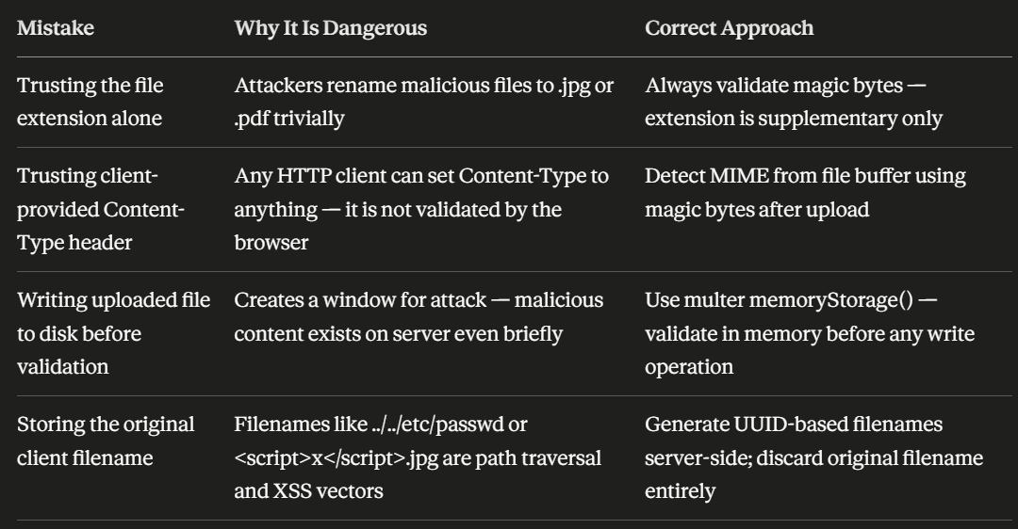
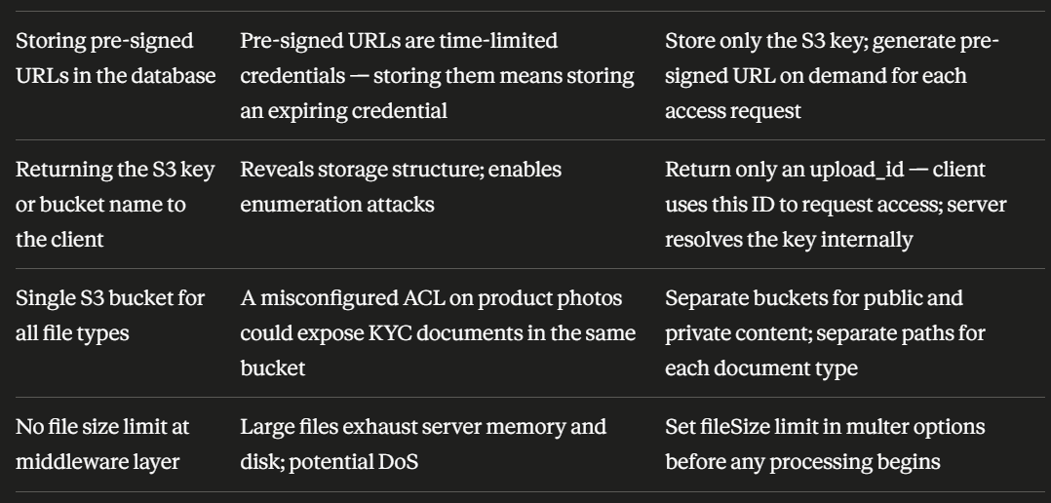
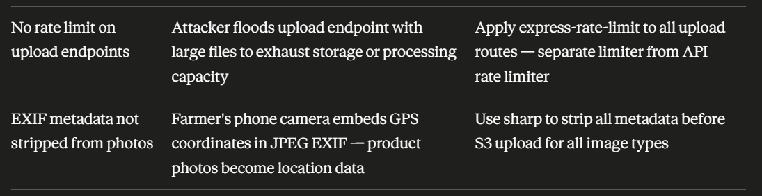

Part F Implementation Checklist

